Team Contract

| Member: | Student Number | Signature |
| --- | --- | --- |
| Tejveer Goga | 501088306 |  |
| Joaquin Kataoka | 501104688 |  |
| Adrian Parungao | 501102077 |  |
| Bilal Asghar | 501113295 |  |
| Hamza Malik | 501112545 |  |

The Team contract is for the benefit of the team.

Accountability

* Responsibility for your own work
* Focus on what is best for the team
* Show up to meetings
* Keep All Members Informed of new updates

Participation

* Be Open and Honest
* Provide equal opportunities for participation amongst all group members

Communication

* Try to stay on track during meetings
* Try to keep up to date on communications(i,e emails, texts, etc)
* Present our ideas is a clear and orderly fashion
* Making sure criticism remains constructive
* Work through problems as a team rather than falling behind
* Let Team Members know if you are missing a meeting or are behind in your role

Problem Solving

* Use constructive criticism
* Holding Accountability based on standards outlined in the Team Contract
* Analyze possible problems and solutions

Task Outline:

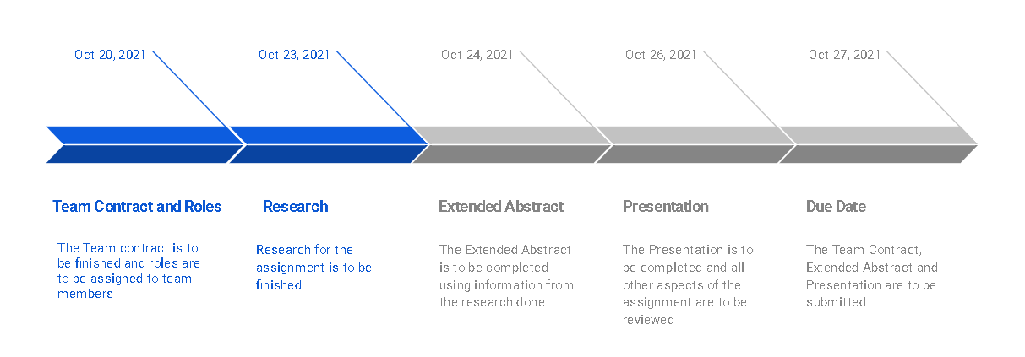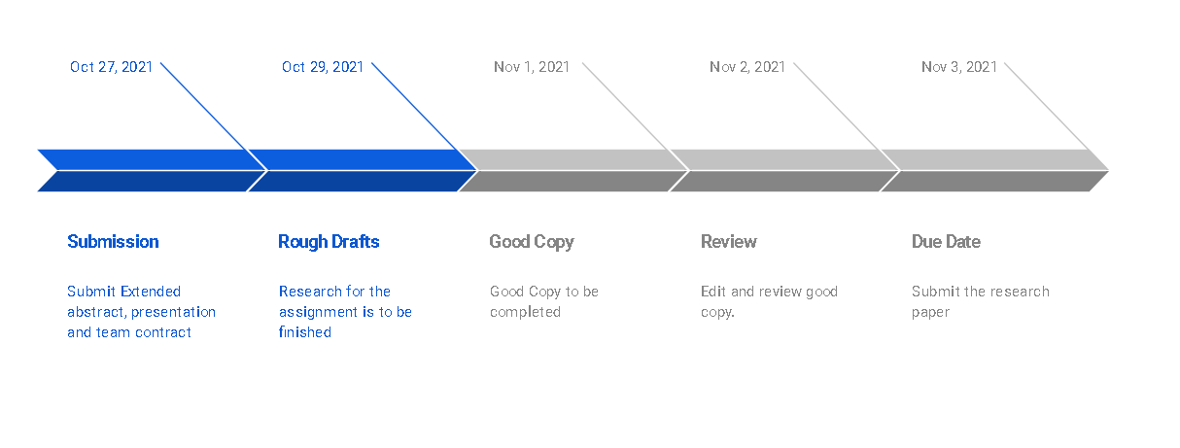

* Abstract-(Bilal)
* Introduction and background-(Bilal)
* Analysis and investigation
  + Causes-(Hamza)
  + Impacts-(Adrian)
  + Ethics and professionalism-(Joaquin)
* Recommendations-(Bilal)
* Conclusion-(Adrian) (Hamza)
* Acknowledgements (Tejveer)
* References (Hamza)
* Breakdown of duties and responsibilities (Tejveer)